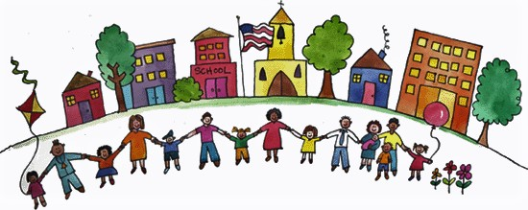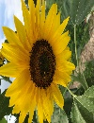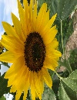
JOIN OUR COMMUNITY GARDEN!
GROW YOUR OWN FOOD AND FLOWERS!
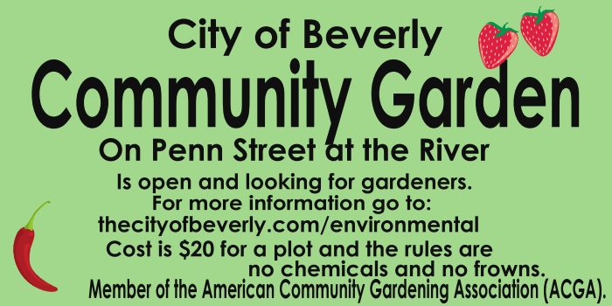
PICK UP AN APPLICATION AT CITY HALL OR ON THE WEBSITE thecityofbeverly.com/environmental OR
CALL 609 747 8048 OR STOP BY FOR A TOUR!

